Now we will wrote code to make our player move so lets go and start writing that
Now we will add the Player script to the Player IOA in Heirarchy or Scene Panel(as we know from our previous lessons) and start editing it It will look like below.
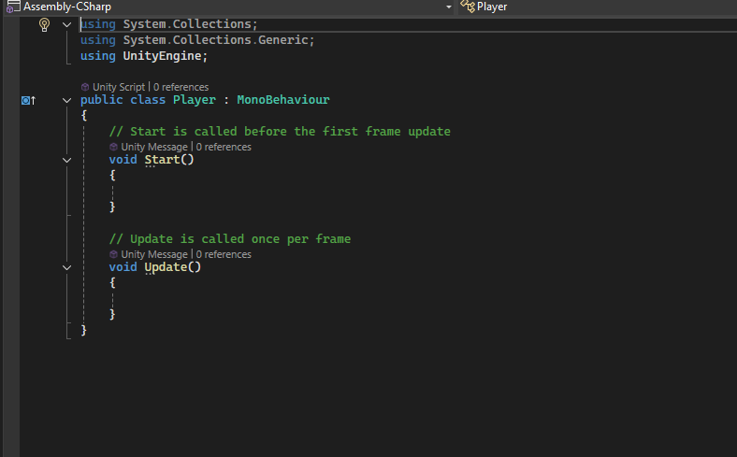
So first all we need few variables which is public
_______________________________________________________________________________Note from future:-
these public variables will be shown in script component as a seperate field where you can put your value matching the data type of the variable here you can dynamically tune the script according to your need
So now we are going to write public float moveSpeed
So this will decide how faster the player will move Then we need a reference to the Rigidbody 2D that we attached to our player IOA (may be that object will be given by the framework
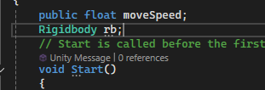
You can see that Rigidbody rb is not public this actually says that it will be provided by the code not by the user(maybe)
The rigidbody will help us to move the player left and right
Now you can also write wake function(in future)
but we will write the code in start function
Start is called before the first frame update
So we will use this rb variable to move all the player do all the physics function and perform all the physics operation on the player.
Note:-
So i have come to the conclusion that there are two coordinates in Unity First is World coordinate
Its position is generally in the center of the screen where our camera is present and screen coordinate origin is in Top left part of the screen. Many things in Unity use different coorinate positioning in Unity.
As we know the update method is called after every frame There is a method called GetMouse button(0) which tells that whether that there was a touch happened behore this method was called
by returning boolean values.
It does not matter that whether you take Vector2 or Vector3 if you are working on a 2D project
as Vector 3 already have two coordinates
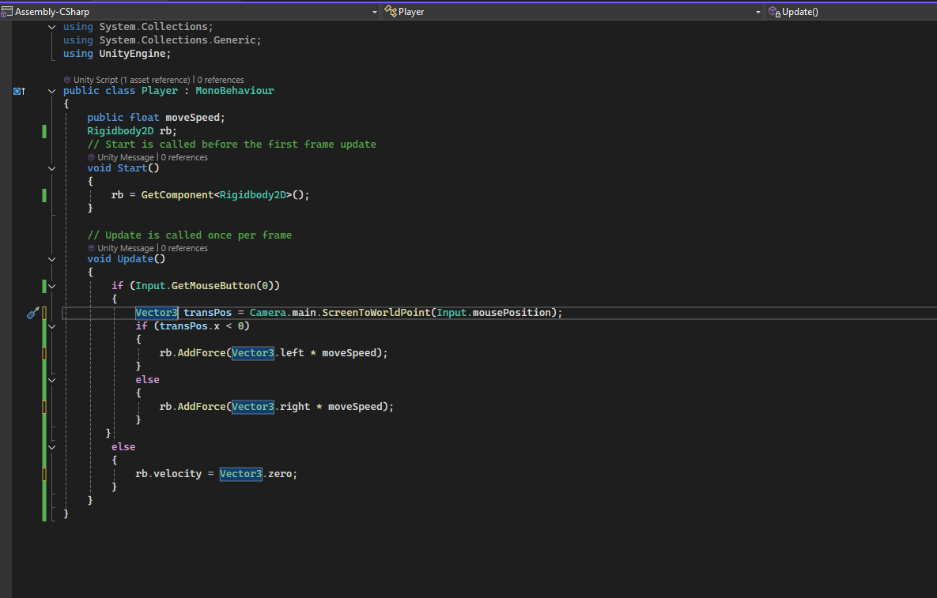
In above code we in start method we get the Rigdbody2D component attached to the object whose script we are trying to write by the method GetComponent<RigidBody2D>()
and then in update method we check whether the mouse is currently pressed on the screen before the Input.GetMouseButton(0) was called . If it return false then we set the velocity of the IOA by taking its rb variable member which is velocity and then set it ot Vector3.zero to stop the IOA if there is no mouse is pressed on the screen and if it returns true then Input.mousePosition return the position of the mouse according to the screen coordinate and then we convert the position according to the World Point by using method Camera.main.ScreenToWorldPoint() and now we store it inside variable named as transPos which is of Vector3 class type. Now after converting our position from screen to world point the position will take origin from the center due to which negative stands for left ans right stands for positive value of x
So we check value of x coordinate of the position (that is transPos variable)
If the value of it is negative then method Addforce with argument Vector2.left will run or otherwise method AddForce with argument Vector3.right will run. You can also use negative Vector3.left.
Now you will see when you press on left side then your player will move in left direction and if pressed on the right side of the screen then the player will move in the right direction.
But first fill the values of movespeed(which was public in script) inside the Player(script) component as marked below.

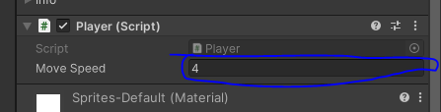
But now when we move the player it sometimes moves out the screen so to stop it we will create an empty object(I think IOA with no image on it) and add them on the either side of the screen.
Now to create it go to
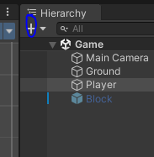
+ button as marked above then a submenu will open like below
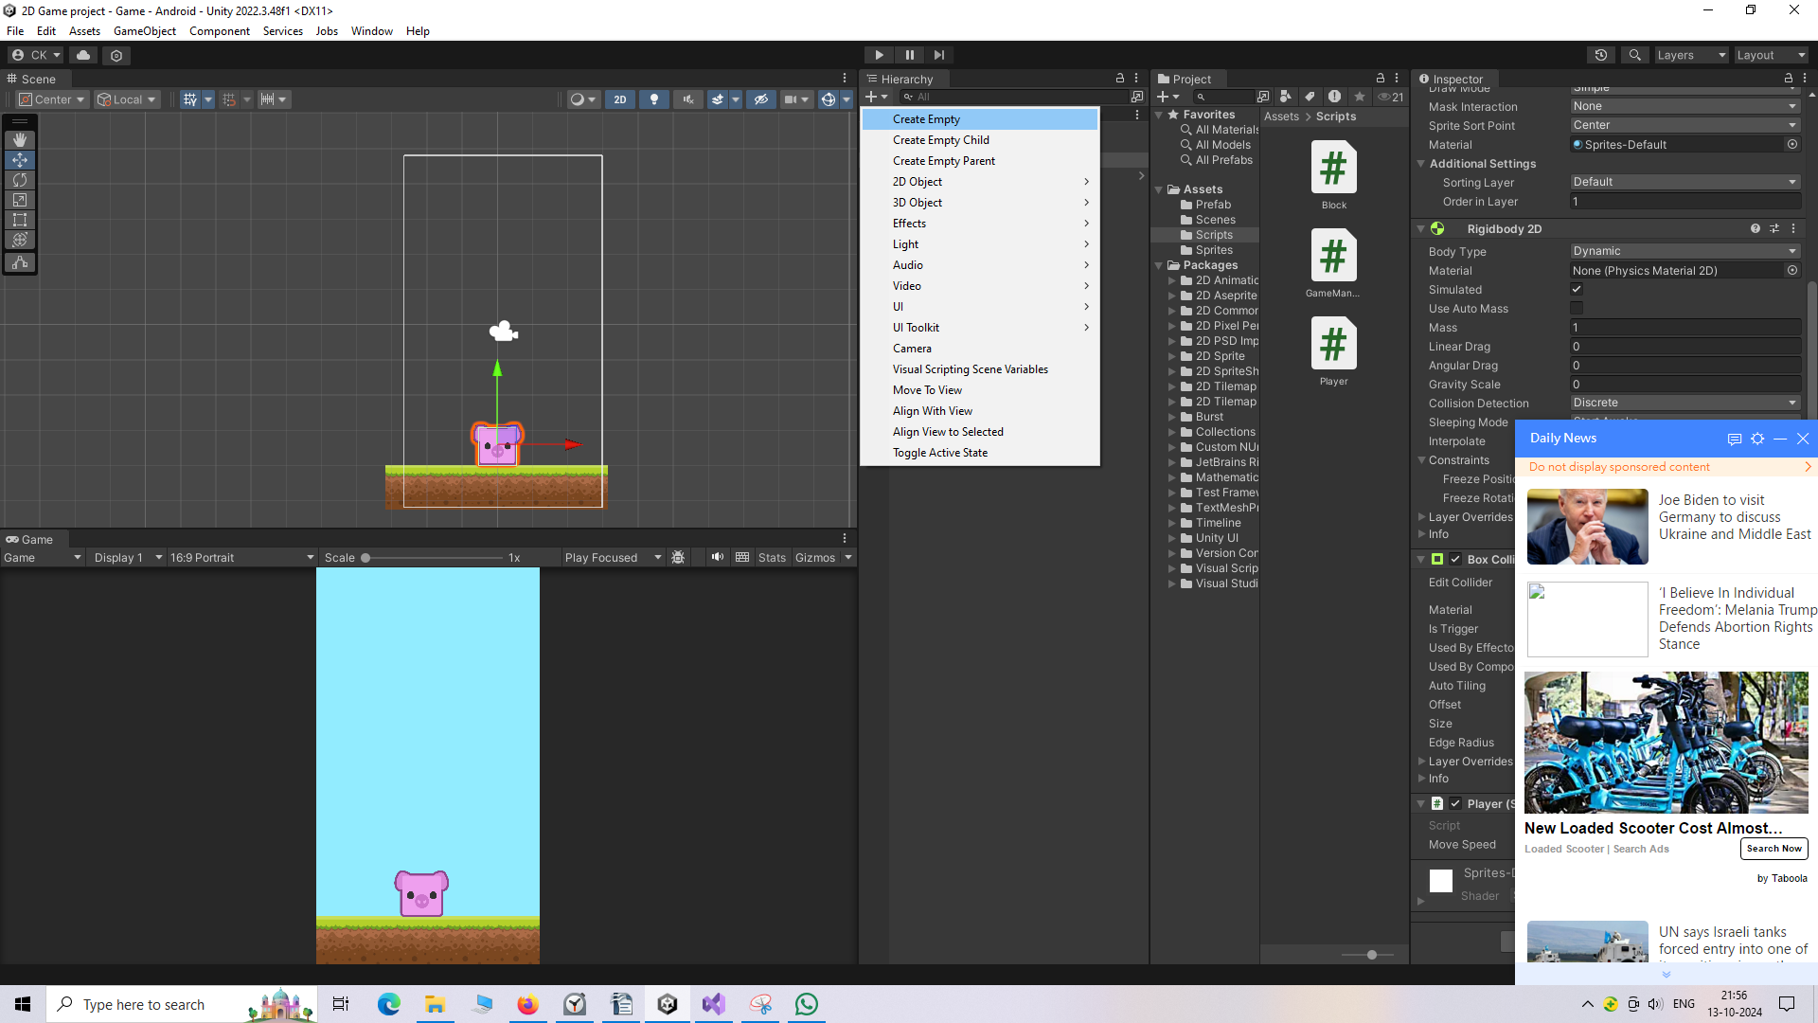
Now click on Create Empty
Now you can see the empty object in the heirarchy panel as marked below
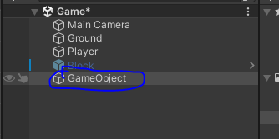
____________________________________________________________________
Note:-
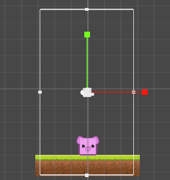
The bounded rectangle is actually bounds of the camera
To reset an IOA means scaling and positioning an IOA according to the standard defined by unity
means in the cener of the screen and a default size when it was first imported in Heirarchy panel or Scene Panel.
Now to set an IOA to reset
first select then go to inspector and then in transform panel
click on the marked area as below
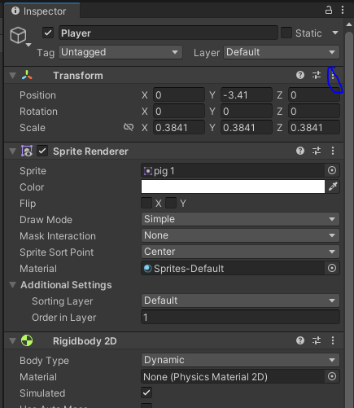
and then a submenu will be opened
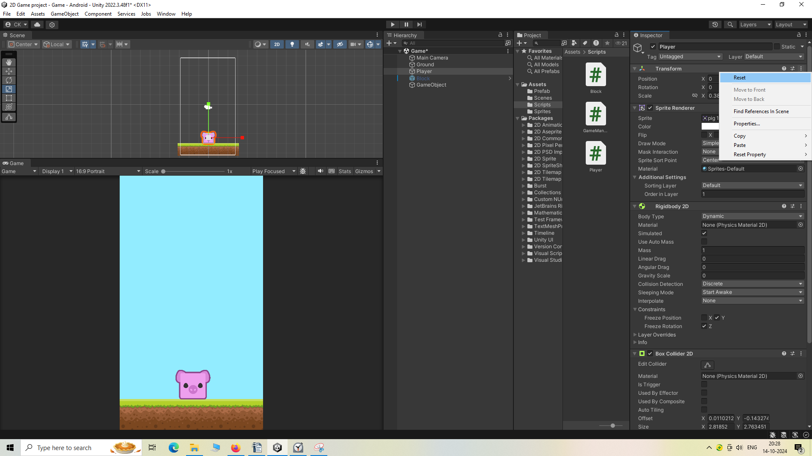
Now click on reset option then that IOA will be reseted.
We will apply the component BoxColllidor on the empty object and put it in bottom of left edge.
And then change its box collidor 2D as discussed till now
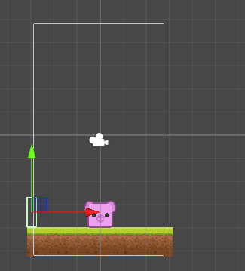
______________________________________________________________
Note:-
when we try to change the collidor box then we just just change its size not the location so it will act as a rectangle tool minus the position change
______________________________________________________________
To duplicate an IOA in heirarchy panel right click on any IOA and then a submenu will be opened like below
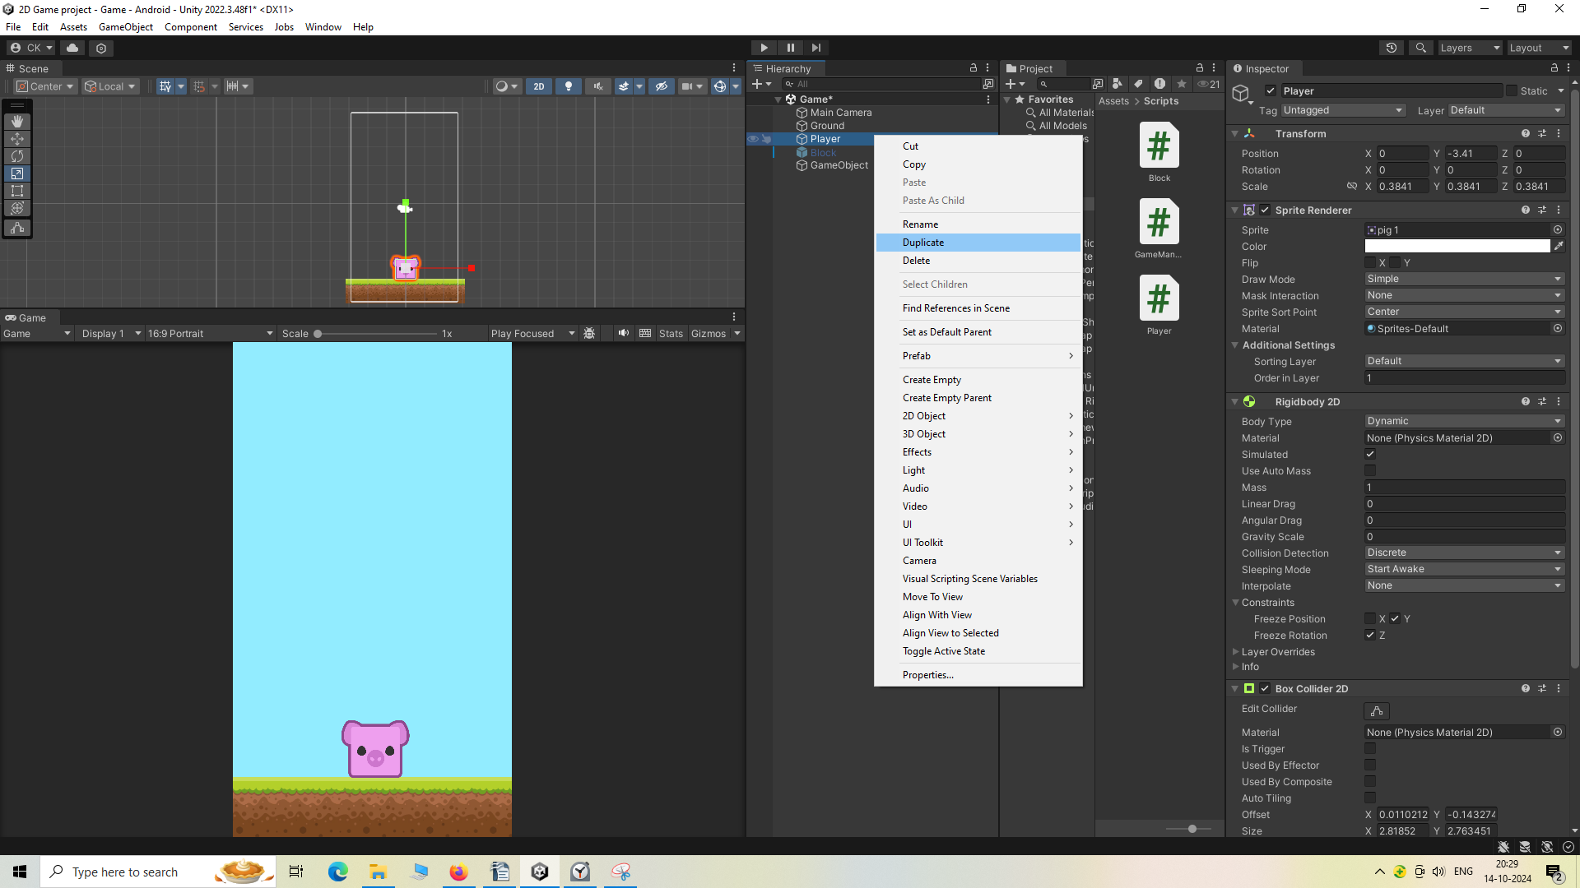
Now go to Duplicate option
Its duplicate will be created below that object
Now we put a duplicated empty object in bottom part of right edge.
By just making its x axis positive as now it will iomplement mirror displacement of duplicated
empty object which is in the same location of original empty object
So now it will look like below
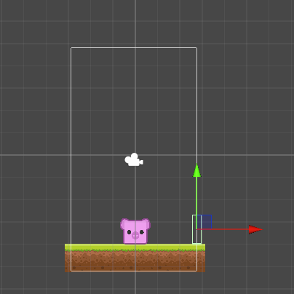
now you can see that our player is not moving out of the screen as when it does it get collided with the empty object
So now both the empty object will act as a boundry in our game
We create another empty object and name it walls
Now we will select both the empty boundry objects so we will select both of them and then drag and drop it on the wall empty object
Now the wall empty object will now act as a parent IOA which will group these empty objects(may be we will see it more in future) and now they are the child of wall empty object.
So our player functionality is always done
Now we need to write some code so that the player can check whenever it collides with the block and restart the game.
So now got that in our Player class in Player script we will create another method member that is OnCollisonEnter2D Which will be called automatically when the player IOA get collided with any other IOA who also have Boxcollidor2D component added to it
Now the code will look like below
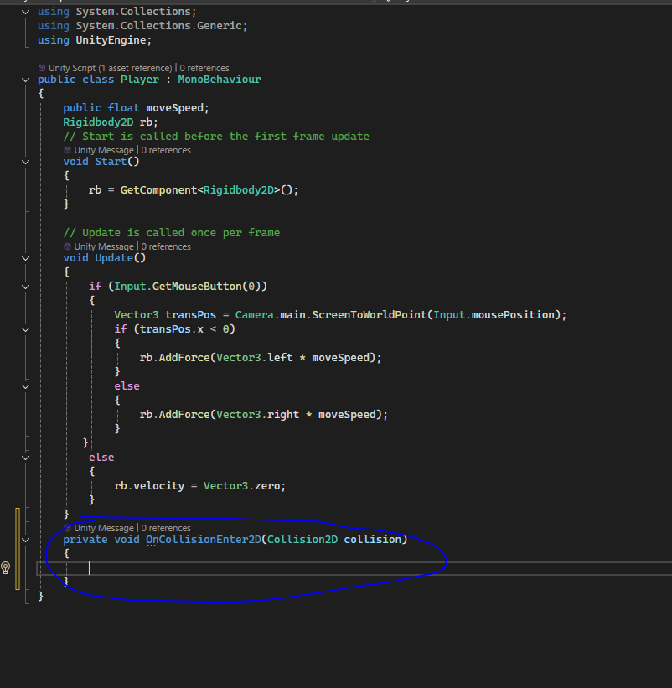
and you can see the OnCollisonEnter2D method as marked above
and in that code the cllison object is the object(IOA) to which our Player is collided
and then we will see it properties gameObject.tag
If it matches with the "Block"(which is a tag added to the block IOA) string then we will reload our scene so that we can restart the screen because the game is now over
Now inorder to reload the scene we need to import some new things
So we're going to write "using Unity Engine dot Scene management".
So this will help us to manage the scenes and reload the scenes.
And now our inside the if "block tag" condition we will write the code
SceneManager.LoadScene(0)
Inside the LoadScene argument you can write "Game" which is the file name of the file inside the script folder
We also can use zero inside our argument because we have only one scene in our build
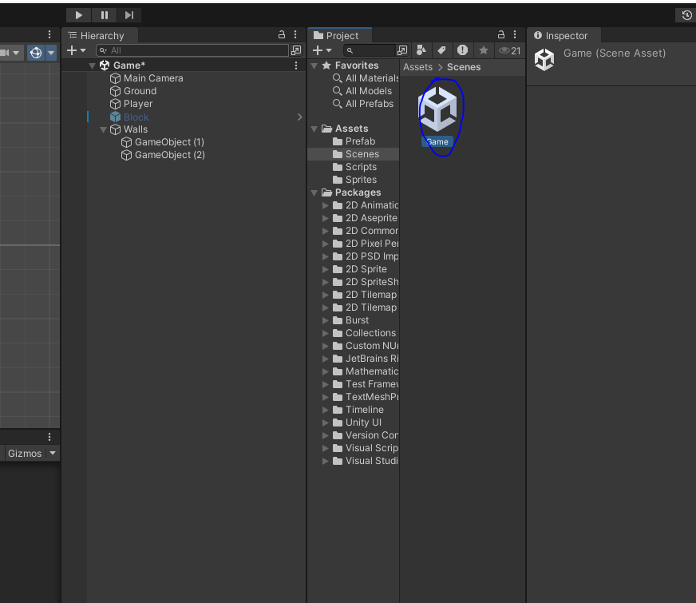
so that the zeroth scene or the first scene will load automatically
So whenever our player get collided with the block
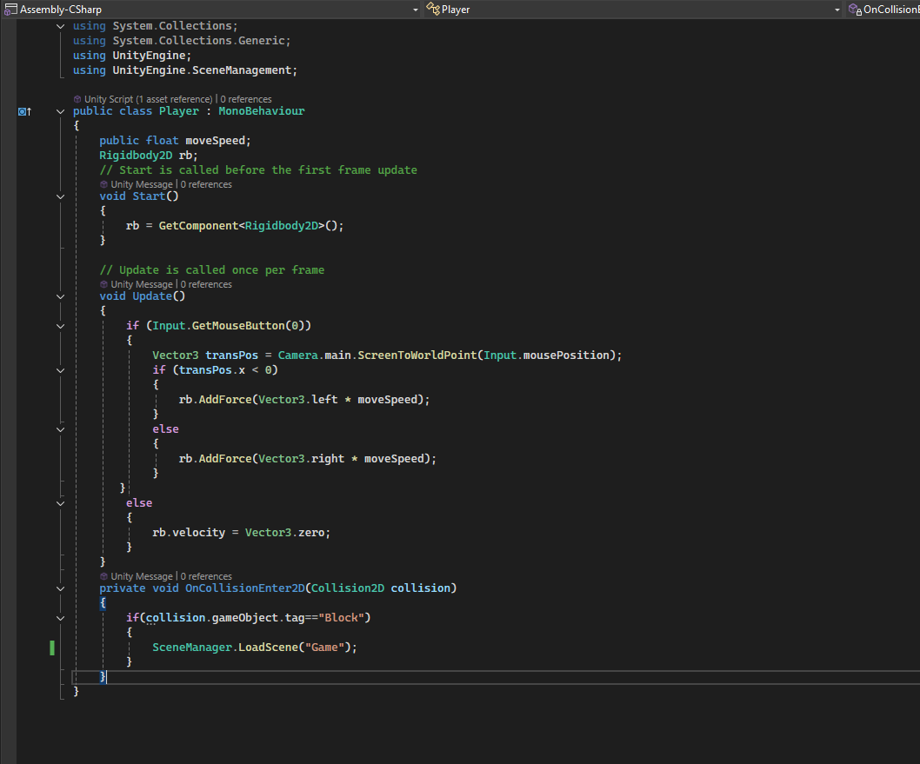
Now we will make the block activated in heirarchy panel (which we deactivated in previous lessons
after making it a prefab) for testing purposes.
So now when the block gets collided with the player the game gets restarted and when it does not touch the player then the block will get destroyed after touching the bottom but not will restart the game.

